PPE and Applicable Apparatus Necessary to perform Inspections.
Protective device | Image | Type of Protection
Safety Spectacles | 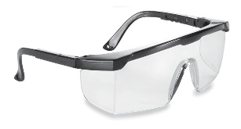 | Shields eyes from small flying objects, glare & heat
Goggles | 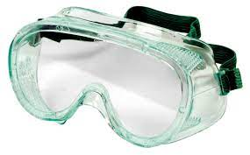 | Protects the eyes from flying objects such as large chips, fragments, dust, heat, chemical splashes, mists, vapors, fumes
Welding Shields | 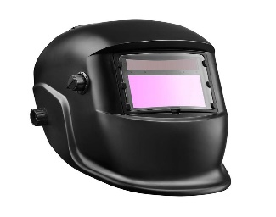 | Protects against intense welding light, sparks, and debris
Laser Safety Googles | 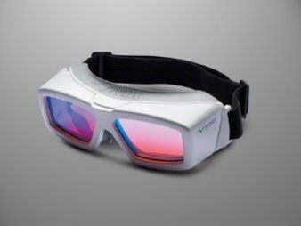 | Designed to reduce hazardous laser eye exposure to safe and permissible levels by providing an optical density (OD) that attenuates the laser you are working with, while allowing enough visible light transmission (VLT) for comfortable visibility in a lab
Face Shields | 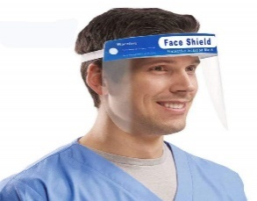 | Provides secondary protection, for the eyes and face, against impact injuries, heat, and chemical splashes
Hard Hat Type I | 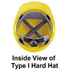 | Intended to reduce the force of impact resulting from a blow only to the top of the head
Hard Hat Type II | 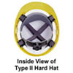 | Intended to reduce the force of lateral impact resulting from a blow which may be received off-center, from the side, or to the top of the head.
Electrical Class E | 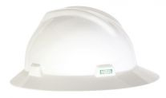 | Designed to reduce exposure to high voltage conductors, and offer dielectric protection up to 20,000 volts (phase to ground)
Electrical Class G | 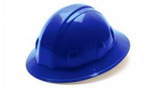 | Designed to reduce exposure to low voltage conductors, and offer dielectric protection up to 2,200 volts (phase to ground)
Electrical Class C | 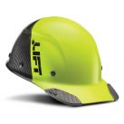 | They are not intended to provide protection against contact with electrical conductors
Leggings | 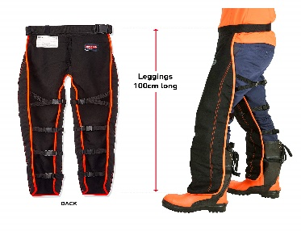
Metatarsal Guards | 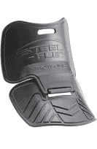
Toe Guards | 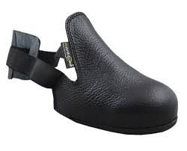
Combination Foot & Shin Guards
Electrically Conductive Shoes
Electrical Hazard Safety Toe Shoes
Leather Gloves | 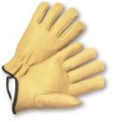 | Offers a good grip, resists sparks, and protects against sharp or abrasive surfaces.
Aluminized Gloves | 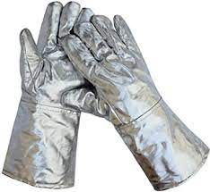 | These are a high-heat-resistant glove, suitable for welding operations and also used in furnace and foundry work or in laboratories with high-heat ovens
Aramid Fiber Gloves | 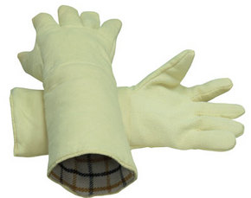 | Protect against conductive and radiant heat
Synthetic Gloves | 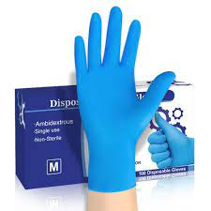 | Synthetic gloves provide better chemical protection
Fabric Gloves
Coated Fabric Gloves | 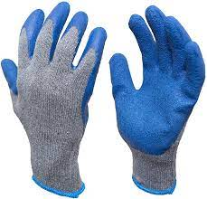 | They offer a higher level of puncture and cut resistance, increased protection from the alkalinity of concrete items such as bricks, and improved chemical resistance
Rubber Insulated Gloves | 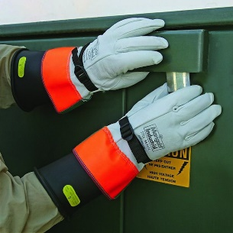 | First line of defense to protect against contact with any energized components or electrical lines.
Butyl Gloves | 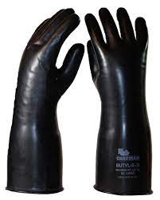 | Made of a synthetic rubber and protect against a wide variety of chemicals, such as peroxide, rocket fuels, highly corrosive acids (nitric acid, sulfuric acid, hydrofluoric acid, and red-fuming nitric acid), strong bases, alcohols, aldehydes, ketones, esters, and nitro compounds
Natural Latex/ Rubber Gloves | 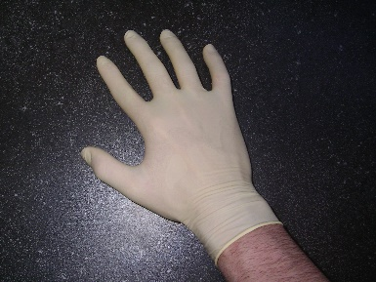 | Intended for incidental contact situations. Suitable for biological hazards and water-based liquids
Neoprene Gloves | 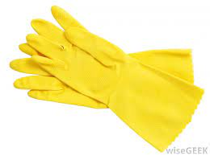 | Commonly used for applications when handling slippery or wet materials safely; protect against a very broad range of oils, acids, caustics, and solvents
Nitrile Gloves | 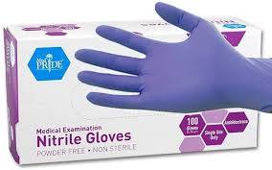 | Protect workers against irritation to the skin, prevent infection, and reduce the risk of burns, cuts, and abrasions
Level A | 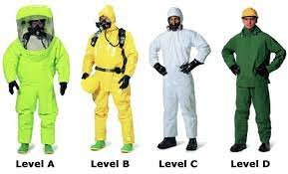 | Unknown environment; confined spaces; environments requiring the highest level of skin, respiratory and eye protection
Level B |  | Must be used when the highest level of respiratory protection is required
Level C | 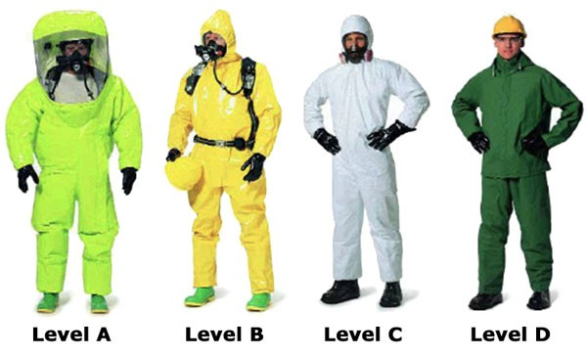 | Must be worn when airborne contaminants are known and the criteria for using air purifying respiratory is met.  Gloves – Outer and Inner  Chemical Resistant, steel toe and shank boots or chemical resistant boots cover
Level D | 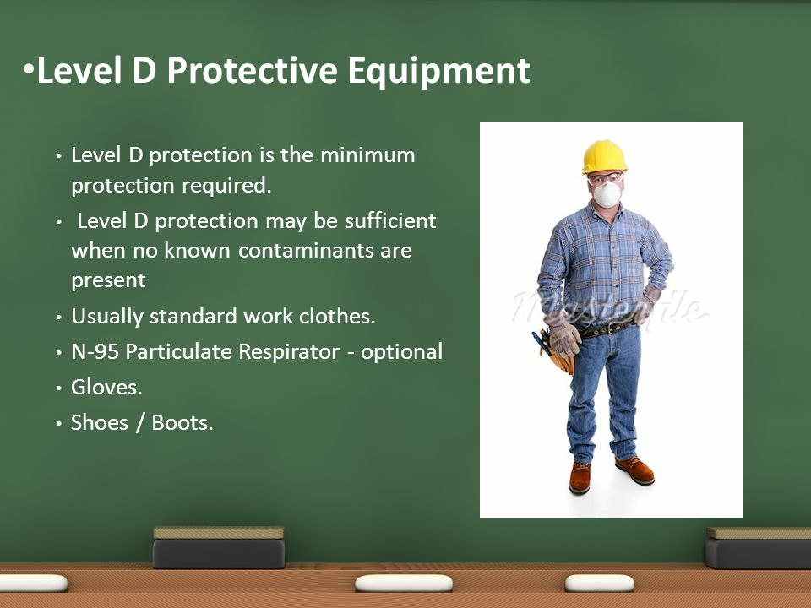 | Minimum protection required. Sufficient when no known contaminants are present. Usually standard work clothes. Gloves. Shoes/Boots. N95 respirator optional.
Dosimeter | 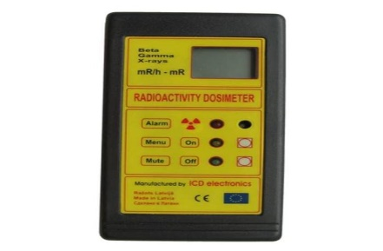 | Measures exposure to ionizing radiation over a given period
Sound Level Meter | 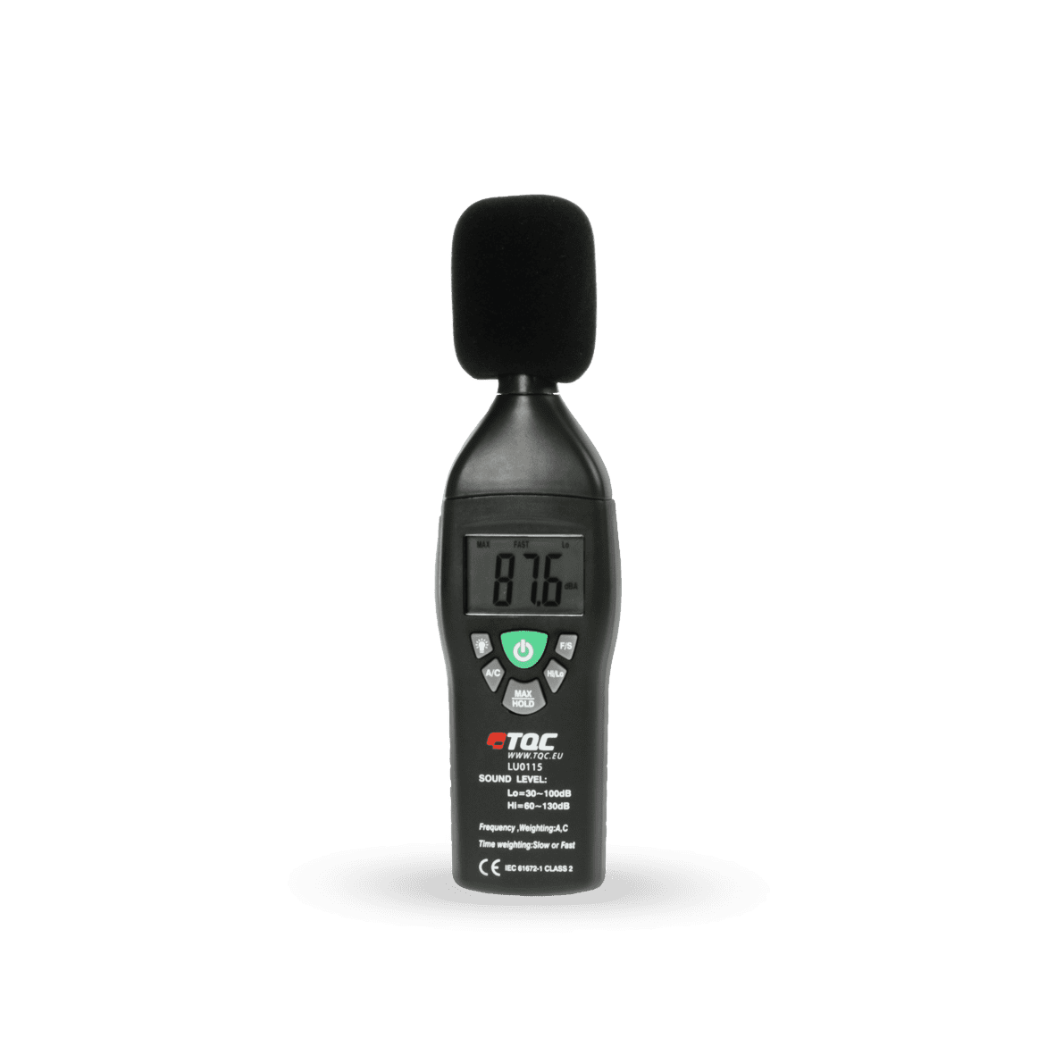 | Measure sound levels in a standardized way. It responds to sound in approximately the same way as the human ear and gives objective, reproducible measurements of sound pressure levels
Air Quality Index (AQI) | 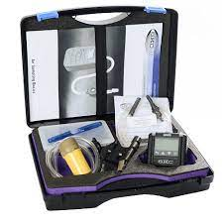 | Measure and report air quality. the AQI looks for five major air pollutants regulated by the Clean Air Act: particle pollution, ground-level ozone, carbon monoxide, nitrogen dioxide, and sulfur dioxide
Tape Measure | 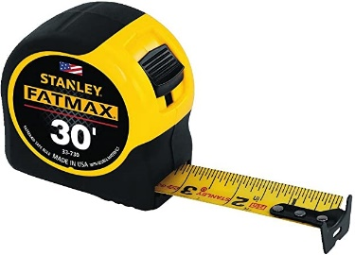 | Measuring lengths and distances
Surveyors Tape | 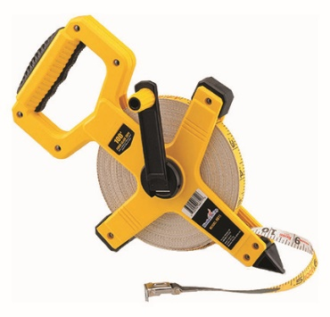 | Surveying to measure horizontal, vertical, and slope distances
Torch Light | 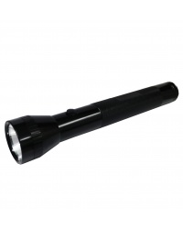 | Used as a light source outdoors, in places without permanently installed lighting, during power outages or when a portable light source is needed
Respirators | 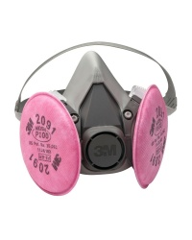 | To protect you from inhaling dangerous substances, such as chemicals and infectious particles
Harness | 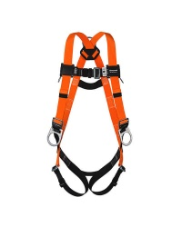 | Serves two purposes: first, distributing fall forces safely across a worker's body in the event of a free fall, and second, providing freedom of movement sufficient to allow the worker to effectively perform his or her job
Beard Net | 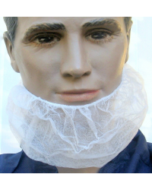 | Prevent human hair from contaminating samples, they can keep long hair from getting caught in rotating equipment
Hair Net | 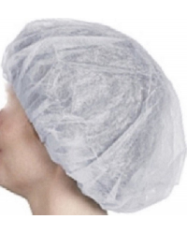 | Prevent human hair from contaminating samples, they can keep long hair from getting caught in rotating equipment
Two Way Radio | 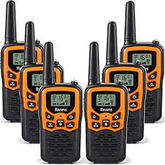
Vest | 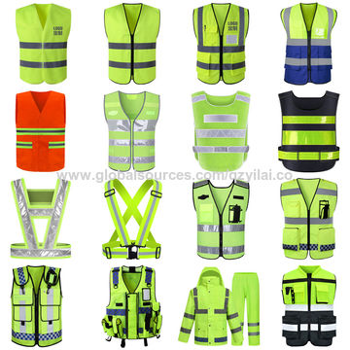
Earmuffs | 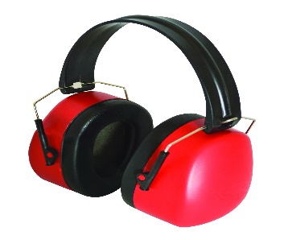
Earplugs | 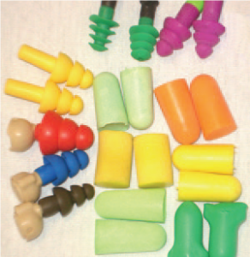
Tablet | 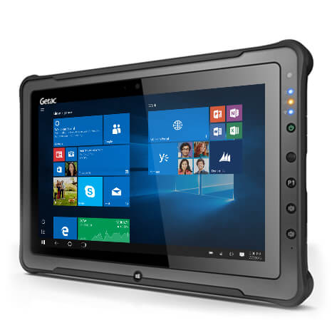
Note Pads | 
Temperature Monitors | 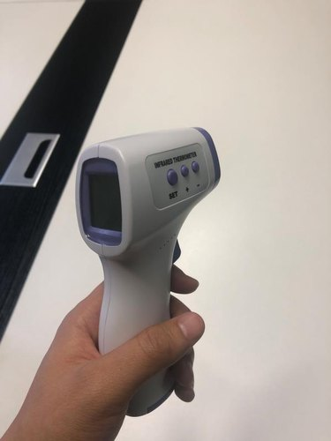
Digital Camera | 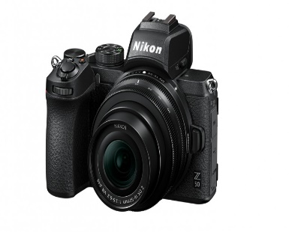
Camcorder | 